**The Battle of Neighborhoods**

Tallmadge, Ohio USA

Applied Data Science Capstone by IBM on Coursera

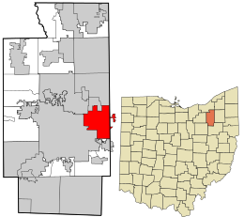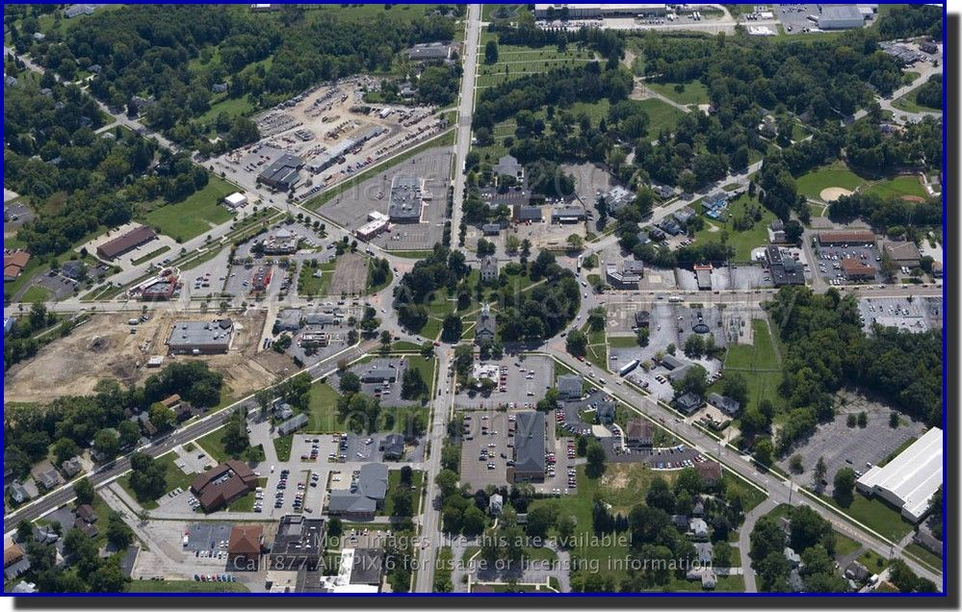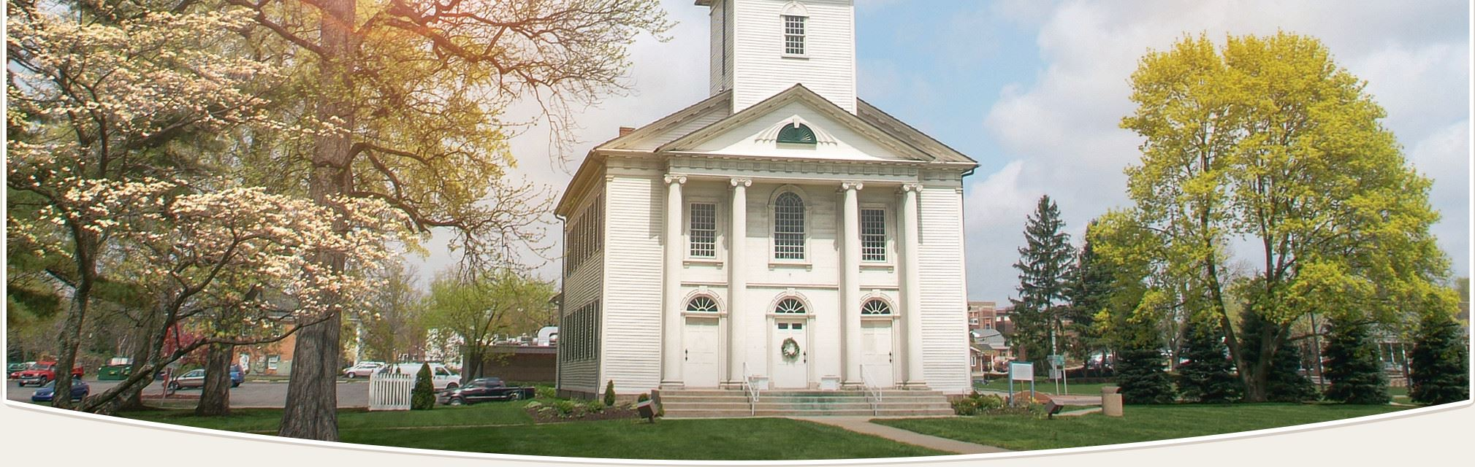

1. Introduction
   1. Background

This project is about the city of Tallmadge, Ohio and where a potential business would want to open up a restaurant there. It is a suburb of Akron, Ohio and has the centerpiece of a roundabout in the center of the city called Tallmadge Circle Park or “the Circle”. In the center of the Circle is Historic Tallmadge Church where it was built in 1825. There are a lot of different business around “the circle” because it is the center point of town.

* 1. Problem

The aim of this project is to see if data can help us make a decision on whether or not a business owner would like to setup a location in Tallmadge Ohio. Some things to note are that the business owns different types of restaurants and would want to know if there is potential for an underutilized type of restaurant. The Data will help us see just how many restaurants and what type/category they are. We are doing very limited market research/exploratory data analysis on this area as real market research would involve speaking to residents of this location and getting feedback before starting a new restaurant in a location.

* 1. Interest

The business would obviously have an interest in this exploratory analysis. They would likely use this data to understand the area. Other stakeholders that may want this information may include the local government for city planning purposes as well as for the purpose of bringing jobs in. Customers might also be interested in learning about this information.

1. Data
   1. Data acquisition and cleaning

I used the FourSquare API to do a search on all of the businesses in Tallmadge, Ohio. I believe this was limited do to having a free version of FourSquare. I ended up having to go back through and filter out non-restaurants to get more of a list of restaurants that I could use for analysis. I created a bar chart using the matplotlib library for Python to showcase some of the different categories of restaurants. This helped a lot with understanding some of the businesses that are already in the area. I also used Folium to get a map of all the different restaurants in Tallmadge centered around Tallmadge Circle. This helped in understanding the positioning of the businesses to see where might be a good spot for a restaurant to open. I did a deeper analysis on the location data using Excel and seeing where to position a restaurant.

* 1. Data Sources/Tools

FourSquare Location data

Tools used: Pandas, Matplotlib, Folium, Excel

1. Analysis
   1. Exploratory Data Analysis

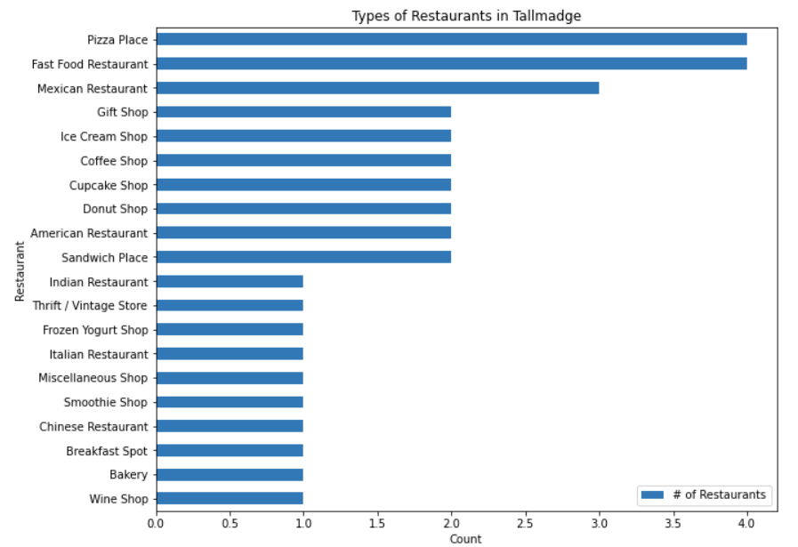

This bar char was created using Pandas data frames and matplotlib. I really like this chart because it tells a lot about the different categories of restaurants. One might infer that since Pizza Place and Fast Food are at the top that you shouldn’t open one of those in Tallmadge and to just open one of the ones with a lot less of that category. However, one can also look at this chart and say there is a big market for Pizza Place’s and Fast-Food Restaurants. One can open a Pizza Place and take the market share from other Pizza Place’s as long as they are unique to the others but it may be riskier. It really depends on the restaurant and the market research conducted with people located within the region. The Wine shop was interesting because when I looked it up, there are no wine shops in Tallmadge and this turned out to be in Kent, Ohio rather than Tallmadge. Later in this report I went a bit further into the analysis and findings.

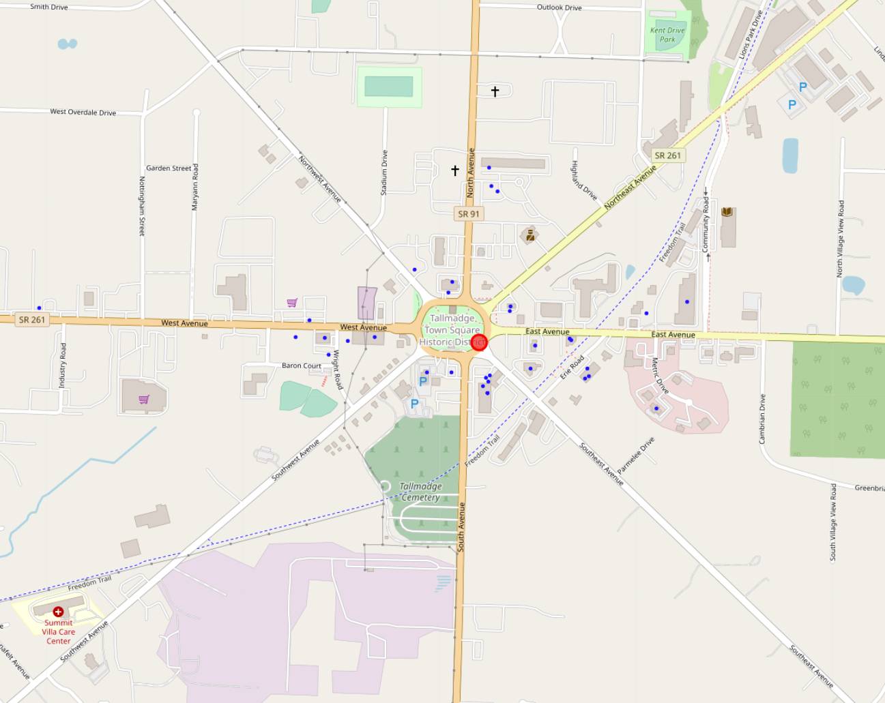

This map was created using FourSquare location data and the Folium library. The red circle represents the address 2 Tallmadge circle which is supposedly the center of Tallmadge circle but clearly not the case. The blue dots represent each restaurant. I thought about using different categories for the colors for the dots, however there would be 20 different categories so every other dot would be a different color. For the purpose of plotting, I think this was the best representation. The graph shows and backs up the fact that all the restaurants are located around Tallmadge Circle. What I thought was interesting is that the restaurants appear a lot more in between the streets more than others. On the next graph I took my findings a little bit further.

This graph was created using Excel. I looked at the number of restaurants in between the street addresses to see if there is an opportunity. It looks like the area between Southeast and East Ave appears to have the most restaurants. Between Southwest and South as well as Northwest and West avenue appear to have only 2 restaurants. This could point to an opportunity to open a restaurant on either of those avenues where there aren’t as many restaurants.

Further Data Analysis of Data Points

I checked some of the restaurants because I was curious. Some of the data points had restaurants that had closed down years ago and were no longer there. Also, some of the points either don’t have addresses or the addresses were just completely wrong. An outlier that I noticed was that there is a wine shop in Kent, Ohio that somehow appeared within the Tallmadge Ohio area. This shows that the FourSquare data isn’t very accurate in seeing what current restaurants are present in this area. Foursquare data may be more accurate in much larger cities other than Tallmadge Ohio.

1. Conclusion

The business owner should consider opening up a Wine shop or a bakery either between Southwest Ave and South Ave or between Northwest Avenue and West Ave given the data provided. The closest wineshop is in another city several miles away. This could prove to be very profitable. However, I think there needs to be more market analysis done on this area to fully come to a conclusion.